Module Name: Shopping Workflow - Amazon
Test Case ID:P–6
Environment:OS: Windows 11, Browser: Chrome, Website: https://www.amazon.in/

- Scenario ID: 1a
- Scenario: View products
Test step:
- Search for a product.
- Enter laptop in the search box.
- Click Search.
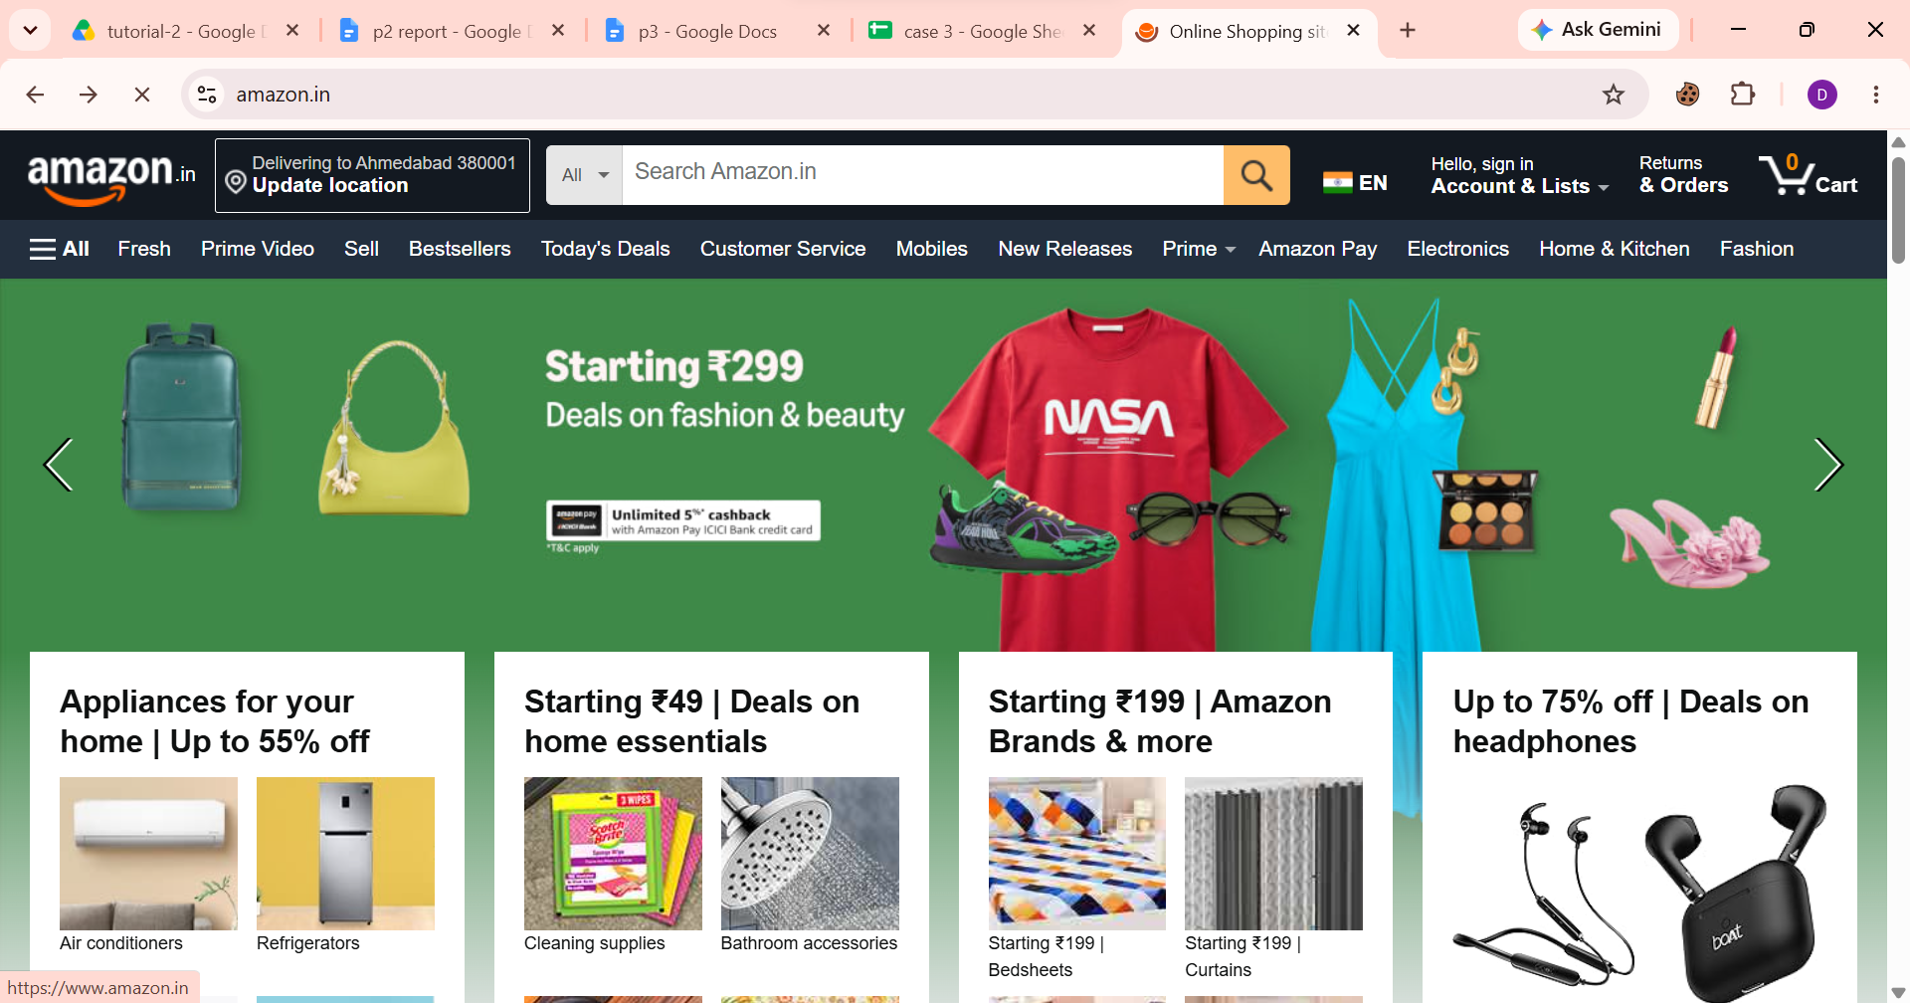
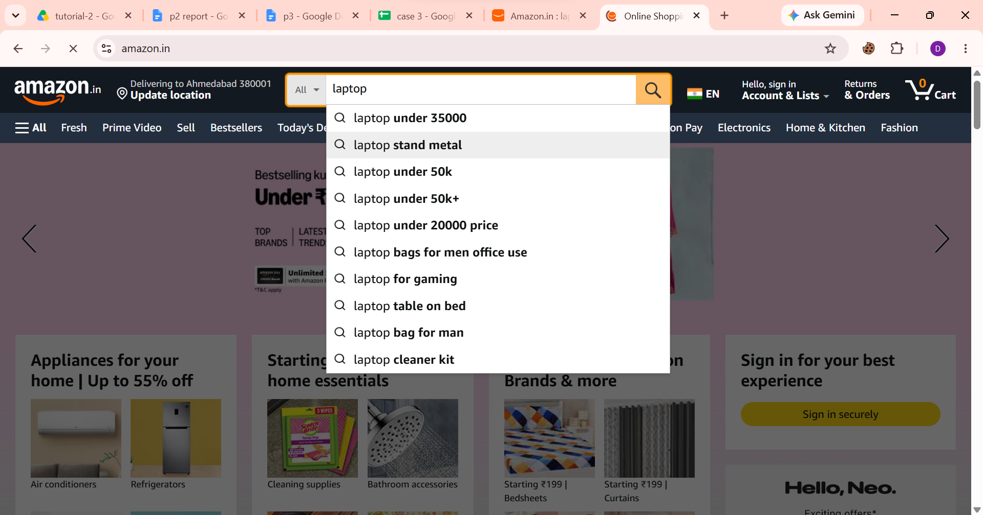

- Scenario ID: 1b
- Scenario: Select product
Test step:
- Open Amazon product listing.
- Select any available product.
- Click on the product.
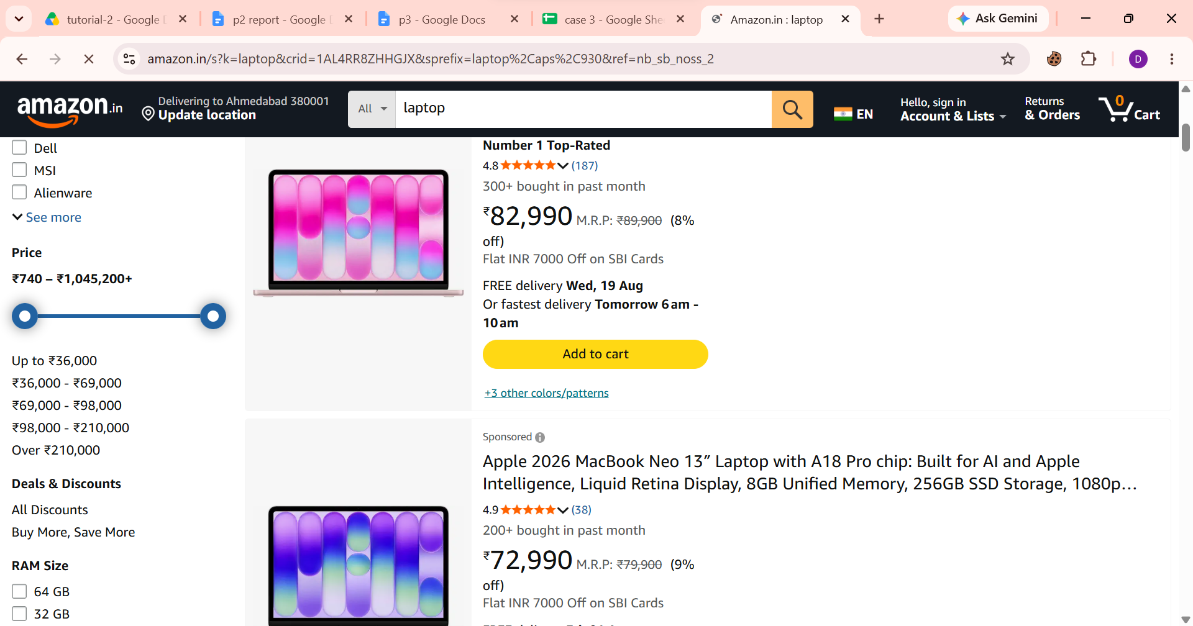

- Scenario ID: 1c
- Scenario: View product details
Test step:
- Open the selected product.
- Check product name.
- Check product image.
- Check product price.
- Check product description.
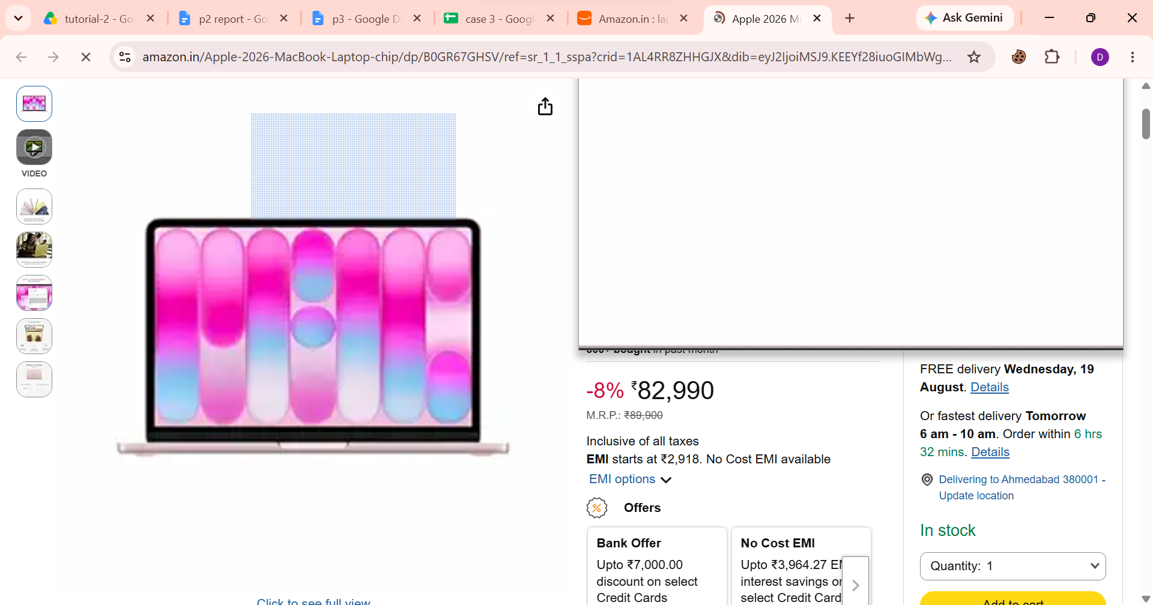
- Check product availability.

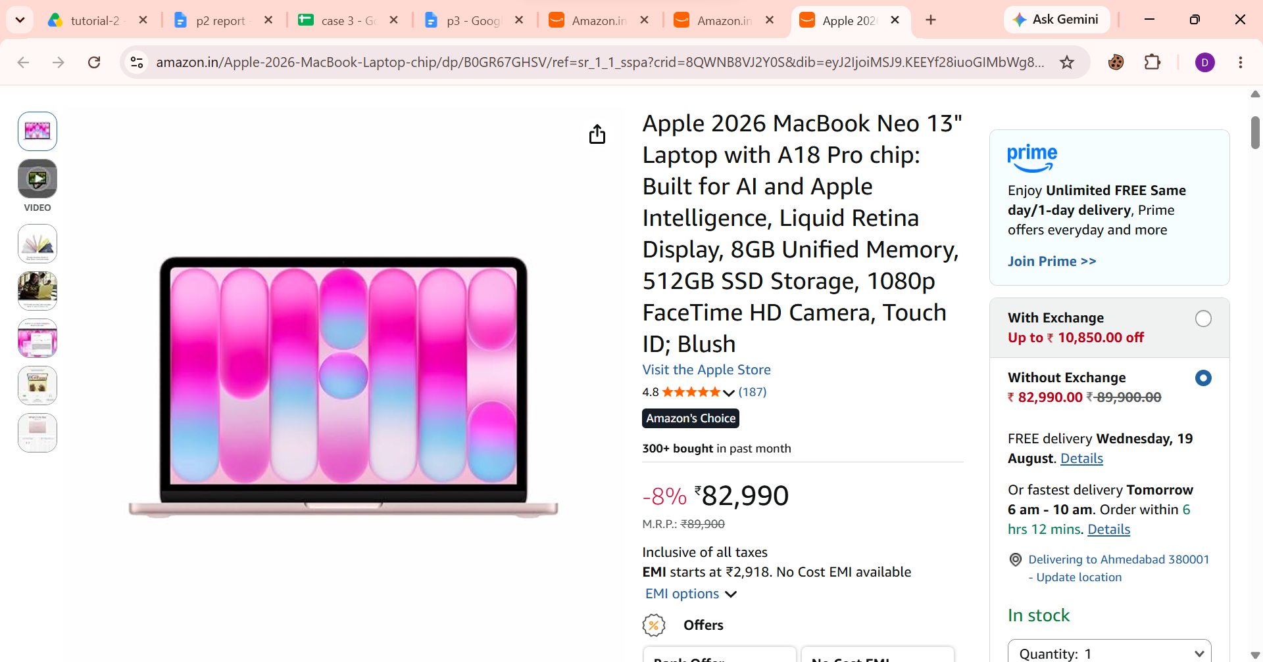

- Scenario ID: 1d
- Scenario: Add product to cart
Test step:
- Open a product.
- Select quantity if required.
- Click Add to Cart.

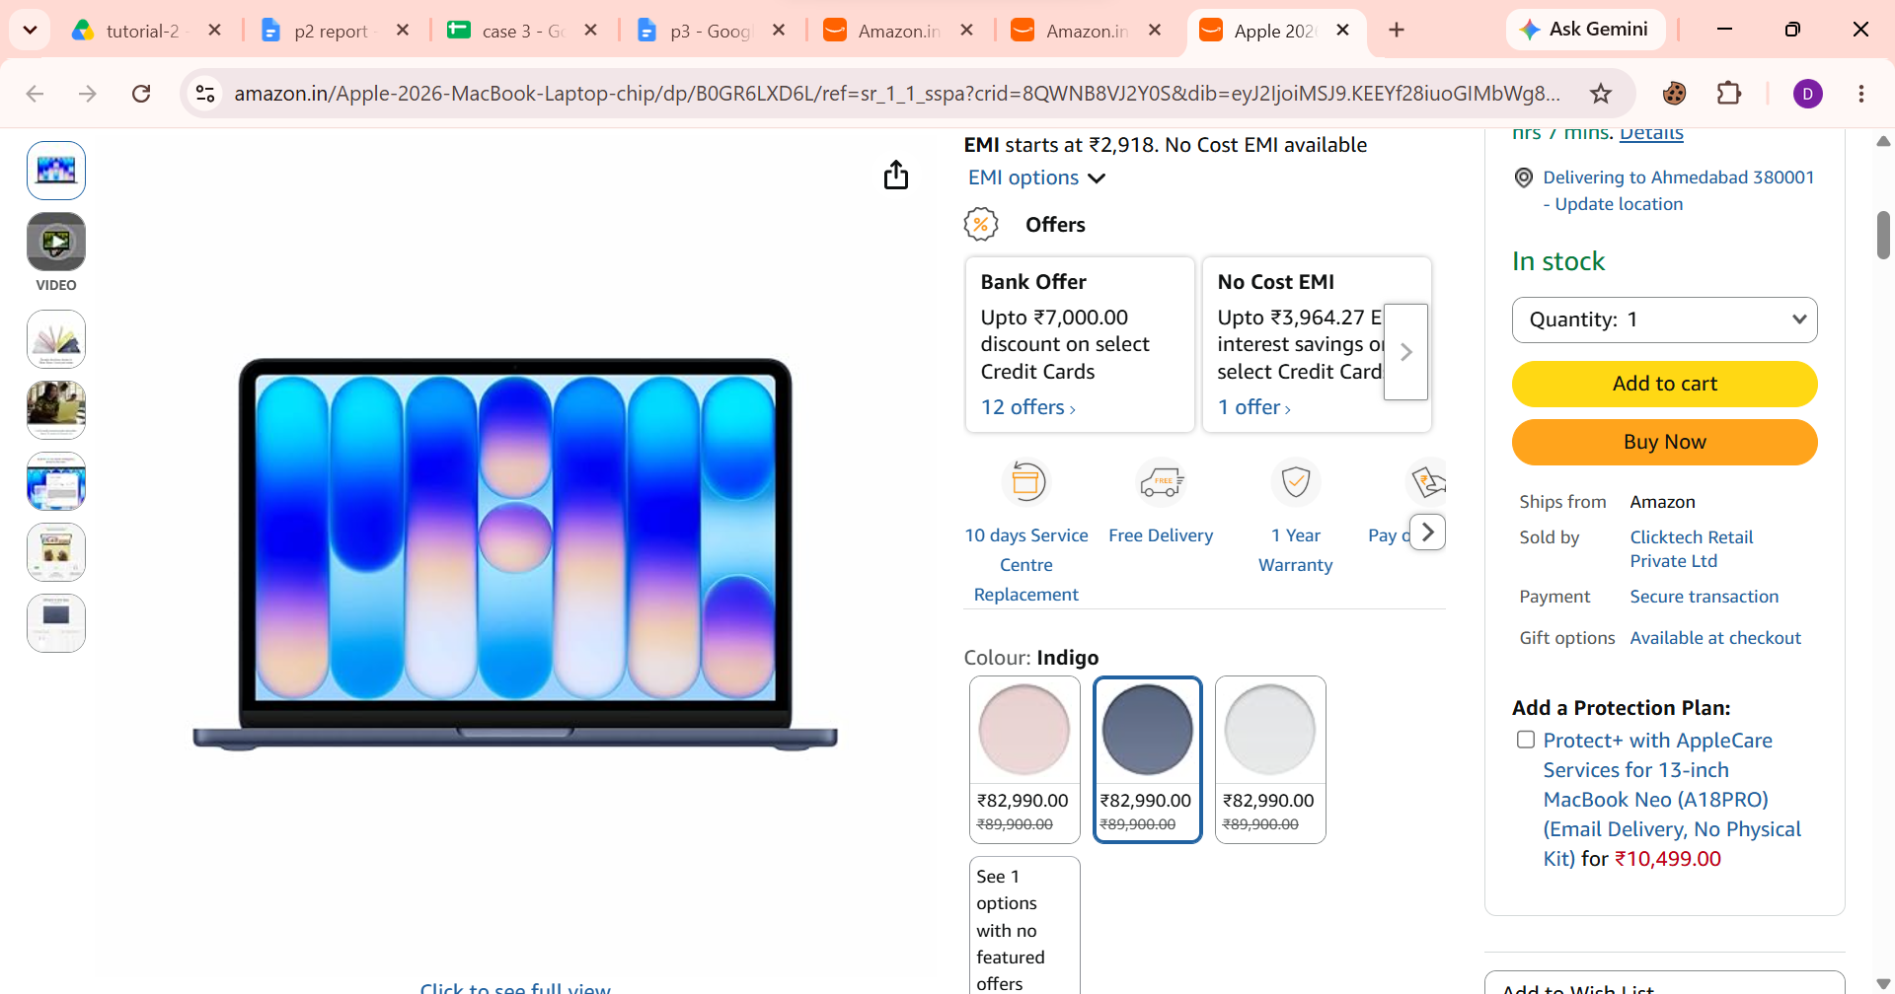

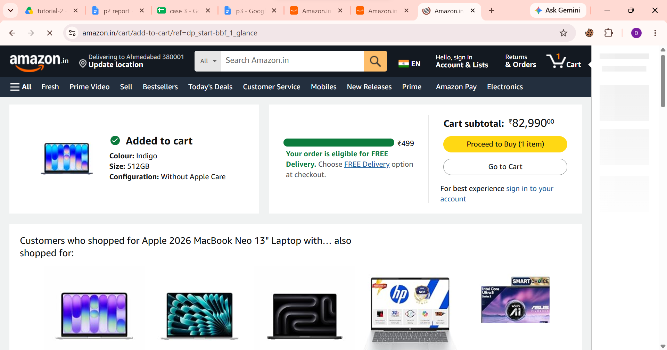

- Scenario ID: 1e
- Scenario: Open cart
Test step:
- Add a product to cart.
- Click the Cart icon.

- Scenario ID: 1f
- Scenario: Verify product in cart
Test step:
- Open Cart.
- Check product name.
- Check quantity.
- Check price.
- Compare with the originally selected product.
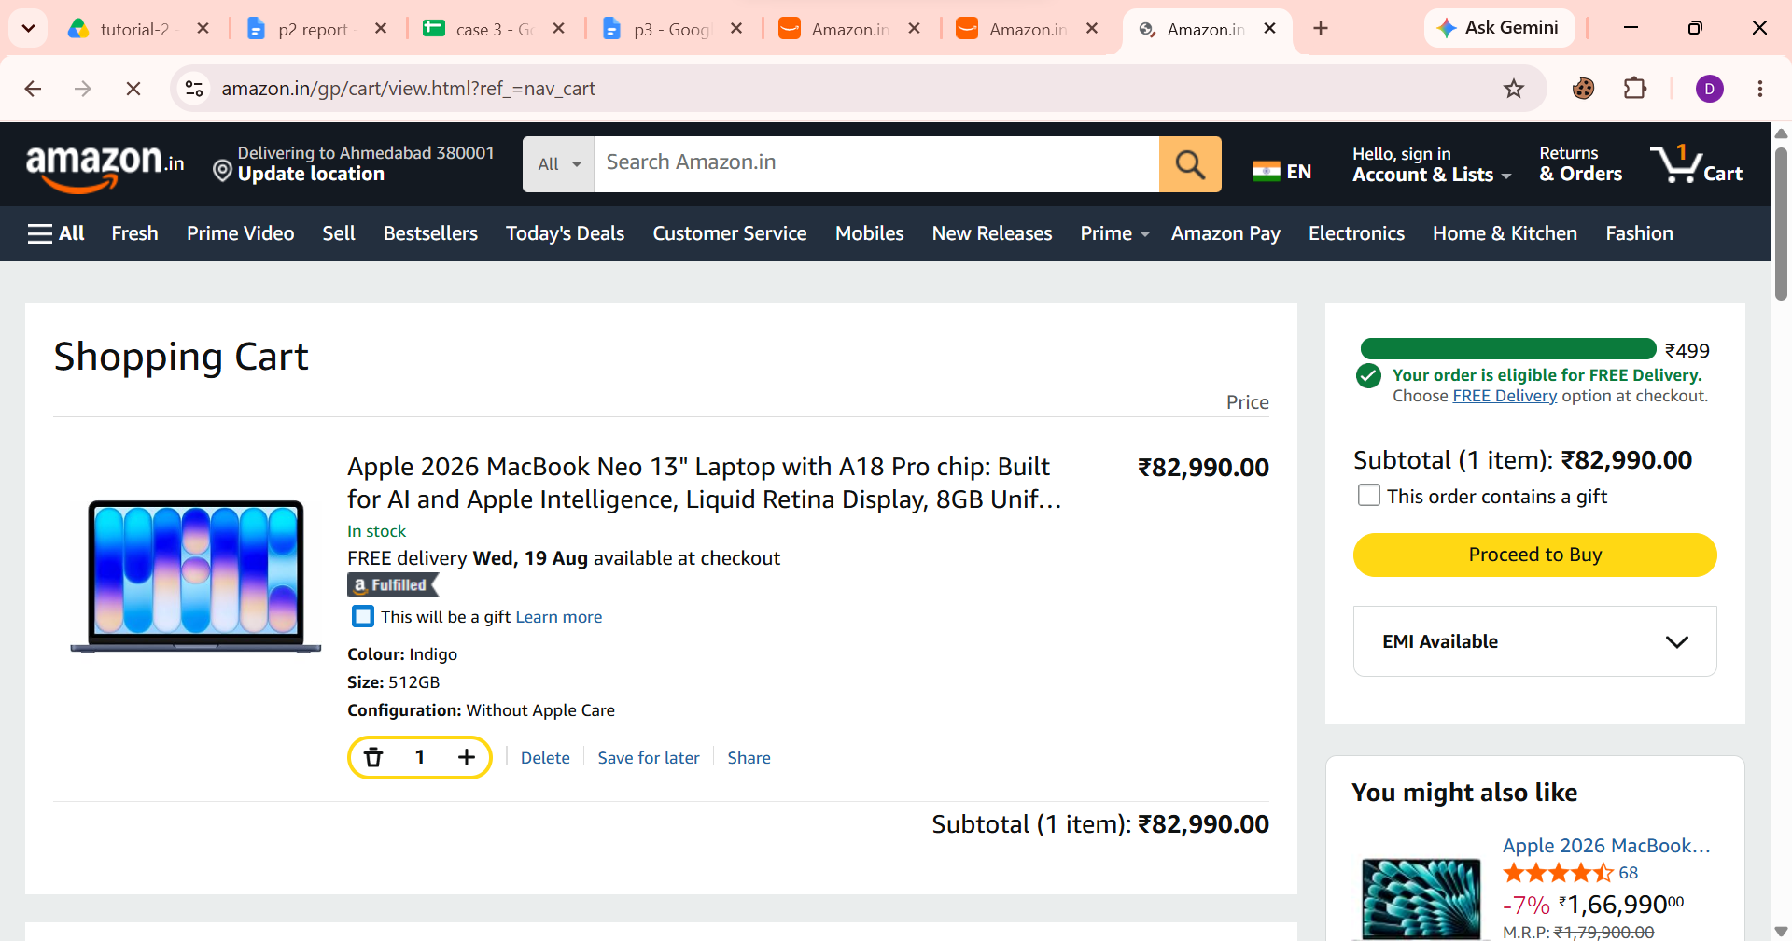

- Scenario ID: 1g
- Scenario: Change quantity
Test step:
- Change the product quantity from 1 to 2.
- Click +.

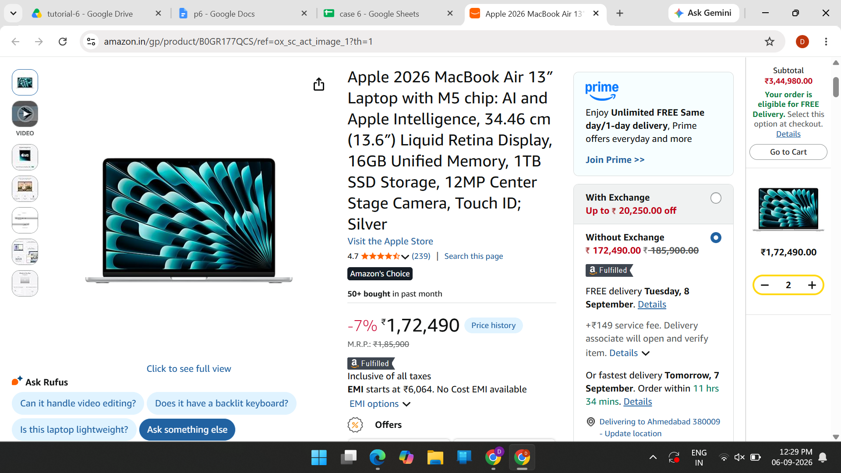

- Scenario ID: 1h
- Scenario: Proceed to buy
Test step:
- Add the laptop again.
- open Cart .
- click 'Proceed to Buy'.

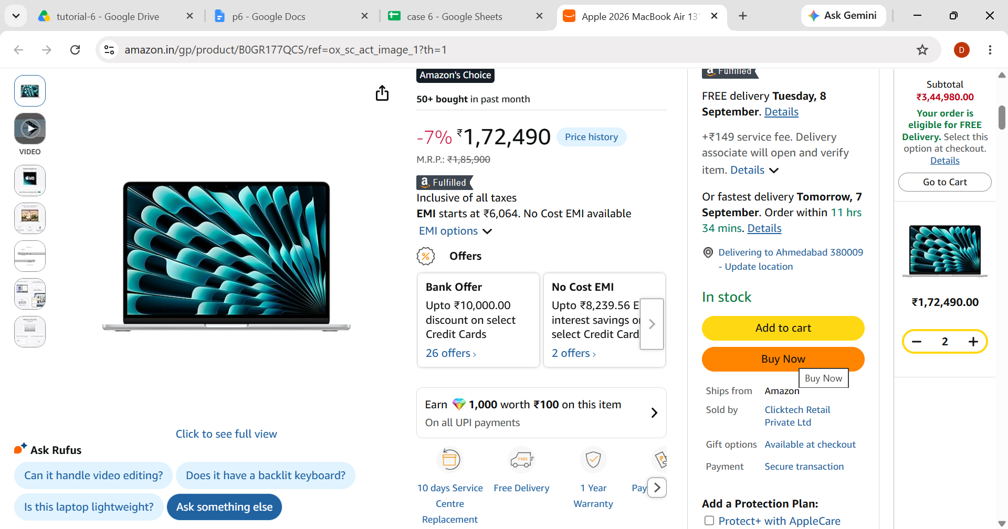

- Scenario ID: 2a
- Scenario: Enter customer details
Test step:
- Enter
- select a valid delivery address
- continue.

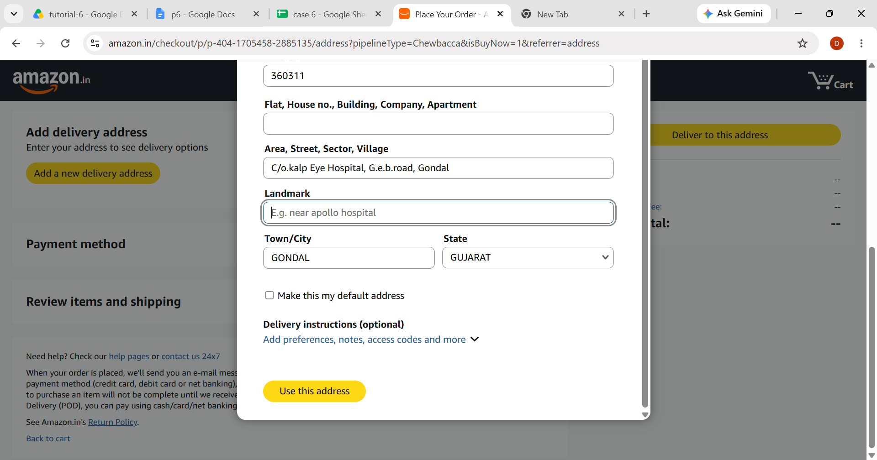

- Scenario ID: 2b
- Scenario: Review and submit order
Test step:
- Review product
- address and payment details
- click 'Place your order' only if permitted.
